EXPERIMENT: 3
DML Commands – INSERT, SELECT
Aim:
To perform Data Manipulation Language (DML) Commands such as INSERT, SELECT in the table.
Description:
Data Manipulation Language (DML) statements are used for managing data within schema objects. DML
Commands: Insert, Select
➢ INSERT - insert data into a table
➢ SELECT - retrieve data from the a database
Questions:
1. Populate all the five tables with your own data.
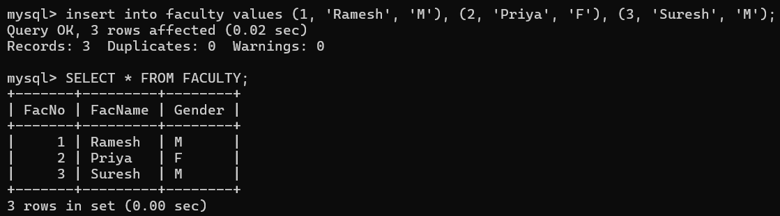
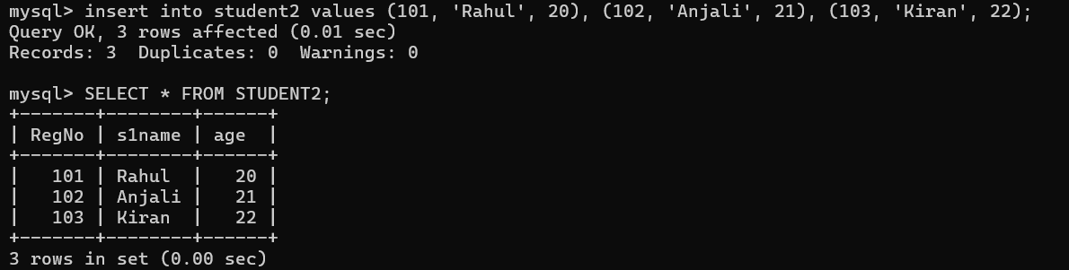
2. View all the records from the five tables.

